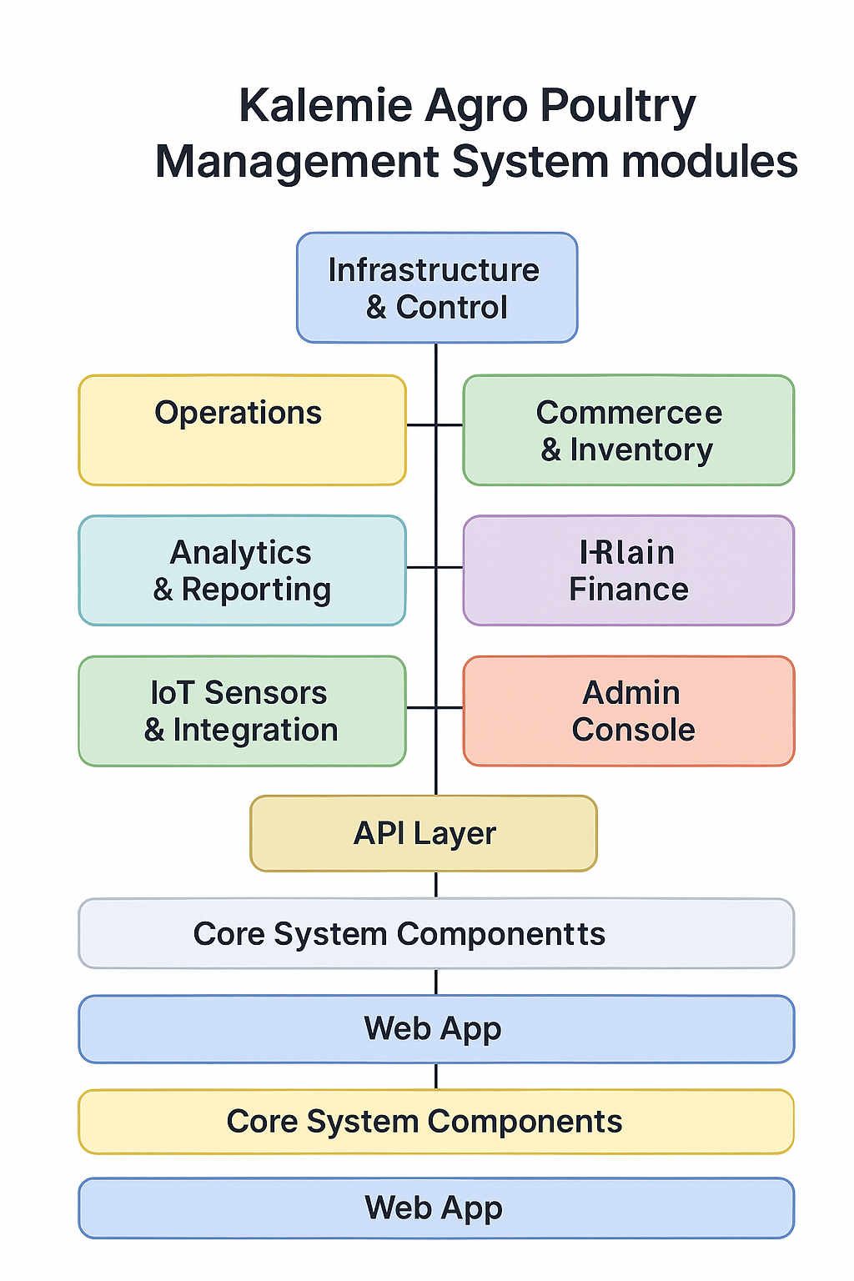 **Kalemie Agro Poultry Management System** modules:

* **Infrastructure & Control**
* **Operations**
* **Commerce & Inventory**
* **HR & Finance**
* **Analytics & Reporting**
* **IoT Sensors & Integration**
* **Mobile App**
* **Admin Console**
* **API Layer**
* **Core System Components**
* **Web App**
* **Public Website**

**A**

**🧱 Infrastructure & Control**

* Manages farm layout, poultry houses, sectors, and user accounts.

**🛠️ Operations**

* Handles bird tracking, feeding, watering, cleaning, and health/vaccination routines.

**🛒 Commerce & Inventory**

* Manages product catalog, stock levels, equipment, and sales.

**👥 HR & Finance**

* Covers employee management, payroll, budgeting, and financial records.

**📊 Analytics & Reporting**

* Provides dashboards, performance metrics, and detailed reports.

**📡 IoT Sensors & Integration**

* Integrates smart sensors for monitoring temperature, humidity, feed levels, etc.

**📱 Mobile App**

* Offers mobile access for staff and managers to interact with the system.

**🛠️ Admin Console**

* Centralized admin interface for system configuration and oversight.

**🔌 API Layer**

* RESTful endpoints for mobile apps and third-party integrations.

**⚙️ Core System Components**

* Includes middleware, RBAC (role-based access control), authentication, and core logic.

**🌐 Web App**

* Web-based interface for daily operations and management.

**🏠 Public Website**

* Marketing and informational site for customers, partners, and investors.

Here are **detailed descriptions** for each module in the **Kalemie Agro Poultry Management System**:

**🧱 Infrastructure & Control**

Manages the foundational structure of the farm:

* **FarmApp**: Defines farm locations and general settings.
* **HousesApp**: Tracks poultry houses and their capacities.
* **FlocksApp**: Manages bird groups by age, breed, and purpose.
* **SectorApp**: Organizes the farm into operational zones.
* **AccountApp**: Handles user roles, permissions, and access control.

**🛠️ Operations**

Covers daily farm activities:

* **BirdApp**: Records bird lifecycle events (birth, transfer, death).
* **FeedingApp**: Manages feed schedules and consumption tracking.
* **WaterApp**: Monitors water supply and usage.
* **CleaningApp**: Schedules and logs sanitation routines.
* **Health-VaccinationApp**: Tracks medical treatments and vaccinations.

**🛒 Commerce & Inventory**

Handles product and stock management:

* **CatalogApp**: Lists farm products (eggs, meat, equipment).
* **InventoryApp**: Tracks stock levels, movements, and alerts.

**👥 HR & Finance**

Manages people and money:

* **HRApp**: Employee records, roles, attendance, and performance.
* **PayrollApp**: Salary calculations, deductions, and payments.
* **FinanceApp**: Budgeting, expenses, income, and financial reports.

**📊 Analytics & Reporting**

Provides insights and performance tracking:

* **DashboardApp**: Visual KPIs (egg production, mortality rate, sales).
* **ReportApp**: Generates detailed reports for operations, finance, and HR.

**📡 IoT Sensors & Integration**

Connects smart devices for real-time monitoring:

* Temperature, humidity, feed levels, water flow, and air quality.
* Integration with external platforms for automation and alerts.

**📱 Mobile App**

Mobile interface for field workers and managers:

* Real-time data entry and access.
* Offline mode for remote areas.
* Push notifications and alerts.

**🛠️ Admin Console**

Centralized control panel:

* System configuration.
* User management.
* Audit logs and system health monitoring.

**🔌 API Layer**

RESTful API endpoints:

* Enables mobile and third-party app integration.
* Secure access to data and services.
* Supports multilingual responses (English & French).

**⚙️ Core System Components**

Essential backend services:

* Middleware for request handling.
* RBAC (Role-Based Access Control).
* Authentication, authorization, and session management.

**🌐 Web App**

Main interface for desktop users:

* Full access to all modules.
* Responsive design for tablets and laptops.
* Dashboard and data visualization tools.

**🏠 Public Website**

Marketing and outreach platform:

* Showcases farm products and services.
* Contact forms and partner information.
* Investor and community engagement.

Would you like this structured into a PDF or added to your README file? I can also generate a bilingual version (English & French) if needed.

Would you like me to generate a new **visual diagram** for this updated structure or include it in your project documentation (e.g., README or business plan)?

* Update the visual diagram accordinglyAdd new modules to README
* Generate detailed module descriptions

Create a summary for stakeholders